A Project report on

BLIND ECG RESTORATION BY OPERATIONAL CYCLE-GAN’s

A Dissertation submitted to JNTU Hyderabad in partial fulfillment of the academic requirements for the award of the degree.

Bachelor of Technology
in
Computer Science and Engineering (AI&ML)
Submitted by

PRANEETH CHAVANA
(23H51A66H5)
SATHVIKA NAMILLA
(23H51A66AD)
SANJANA BADRI
(24H55A6618)

Under the esteemed guidance of
Enoch Raja DG
(Professor)


Department of Computer Science and Engineering (AI&ML)

CMR COLLEGE OF ENGINEERING & TECHNOLOGY

(UGC Autonomous)
*Approved by AICTE *Affiliated to JNTUH *NAAC Accredited with A⁺ Grade

KANDLAKOYA, MEDCHAL ROAD, HYDERABAD - 501401.

2024- 2025

CMR COLLEGE OF ENGINEERING & TECHNOLOGY
KANDLAKOYA, MEDCHAL ROAD, HYDERABAD – 501401

DEPARTMENT OF COMPUTER SCIENCE AND ENGINEERING(AI&ML)


CERTIFICATE

This is to certify that the Major Project report entitled " BLIND ECG RESTORATION BY OPERATIONAL CYCLE-GAN’s" being submitted by PRANEETH CHAVANA (23H51A66H5), SATHVIKA NAMILLA (23H51A66AD), SANJANA BADRI (24H55A6618) in partial fulfillment for the award of Bachelor of Technology in Computer Science and Engineering(AI&ML) is a record of bonafide work carried out his/her under my guidance and supervision.

The results embodies in this project report have not been submitted to any other University or Institute for the award of any Degree.

Ms.Shaheen Fathima Dr. P.SRUTHI EXTERNAL EXAMINER
Assistant professor Professor and HOD
Dept. of CSE(AI&ML) Dept. of CSE(AI&ML)-II

ACKNOWLEDGEMENT

With great pleasure we want to take this opportunity to express my heartfelt gratitude to all the people who helped in making this project work a grand success.
We are grateful to Ms.Shaheen Fathima, Professor, Department of Computer Science and Engineering (AI&ML) for his valuable technical suggestions and guidance during the execution of this project work.
We would like to thank Dr. P.SRUTHI, Head of the Department of Computer Science and Engineering (AI&ML)-II, CMR College of Engineering & Technology, who is the major driving forces to complete my project work successfully.
We are very grateful to Dr. Ghanta Devadasu, Dean-Academics, CMR College of Engineering & Technology, for his constant support and motivation in carrying out the project work successfully.
We extend our heartfelt gratitude to Dr. Seshu Kumar Avadhanam, Principal, CMR College of Engineering & Technology, for his unwavering support and guidance in the successful completion of our project and his encouragement has been invaluable throughout this endeavor.
We are highly indebted to Major Dr. V A Narayana, Director, CMR College of Engineering & Technology, for giving permission to carry out this project in a successful and fruitful way.
We express our sincere thanks to Shri. Ch. Gopal Reddy, Secretary & Correspondent, CMR Group of Institutions, and Shri Ch Abhinav Reddy, CEO, CMR Group of Institutions for their continuous care and support.
We would like to thank the Teaching & Non- teaching staff of Department of Computer Science & Engineering for their co-operation.
Finally, we extend thanks to our parents who stood behind us at different stages of this Project. We sincerely acknowledge and thank all those who gave support directly and indirectly in completion of this project work.

PRANEETH CHAVANA- 23H51A66H5
SATHVIKA NAMILLA- 23H51A66AD
SANJANA BADRI- 24H55A6618

BLIND ECG RESTORATION BY OPERATIONAL CYCLE-GAN’s

DECLARATION

We hereby declare that results embodied in this Report of Real Time (or) Field Based Research Project BLIND ECG RESTORATION BY OPERATIONAL CYCLE-GAN’s are from work carried out by using partial fulfillment of the requirements for the award of Bachelor of Technology in Computer Science and Engineering (AI&ML). We have not submitted this report to any other university/institute for the award of any other degree.

NAME ROLL NO SIGNATURE
PRANEETH CHAVANA 23H51A66H5
SATHVIKA NAMILLA 23H51A66AD
SANJANA BADRI 24H55A6618

CMRCET CSE (AI&ML

CHAPTER
NO. TITLE PAGE N ABSTRACT i
1 INTRODUCTION 1
1.1 Problem Statement 2
1.2 Research Objective 3
1.3 Project Scope and Limitations 4
2 BACKGROUND WORK 5
2.1. Multi-Level Graph Cut + Patch Verification 6
2.1.1.Introduction 6
2.1.2.Merits,Demerits and Challenges 6
2.1.3.Implementation of <Existing Method1 Name> 6
2.2. CNN with Iterative Embedded Graph Cut 7
2.2.1.Introduction 7
2.2.2.Merits,Demerits and Challenges 7
2.2.3.Implementation of <Existing Method2 Name> 7
2.3. YOLO (You Only Look Once) 8
2.3.1.Introduction 8
2.3.2.Merits,Demerits and Challenges 8
2.3.3.Implementation of <Existing Method3 Name> 8
3 PROPOSED SYSTEM 9
3.1. Research Objective of Proposed Model 9
3.2. Algorithms Used for Proposed Model 10
3.3. Designing 11
3.3.1 .UML Diagram 12
3.4. Stepwise Implementation and Code 13
4 RESULTS AND DISCUSSION 14 4.1. Performance metrics 15
5 CONCLUSION 16
5.1 Conclusion and Future Enhancement 17
REFERENCES 20
Publication Details 21
GITHUB link 22

BLIND ECG RESTORATION BY OPERATIONAL CYCLE-GAN’s

ABSTRACT

This study introduces a novel blind ECG restoration approach using cycle-consistent generative adversarial networks (Cycle-GANs) to enhance ECG signal quality, making it suitable for clinical diagnosis despite varying artifact types and severities. To further improve performance, the researchers propose a 1D operational Cycle-GAN with a generative neuron model. The method is extensively tested on the CPSC-2020 dataset, which includes over one million beats, and evaluated through both quantitative analysis and cardiologist assessments. Results demonstrate significant improvements in ECG signal restoration, ensuring reliable arrhythmia diagnosis and paving the way for advanced ECG denoising techniques in medical applications.

CMRCET CSE(AI&ML) Page i
BLIND ECG RESTORATION BY OPERATIONAL CYCLE-GAN’s

CHAPTER 1
INTRODUCTION

CMRCET CSE(AI&ML) Page No 1
BLIND ECG RESTORATION BY OPERATIONAL CYCLE-GAN’s

CHAPTER 1
INTRODUCTION

1.1 Problem Statement
Electrocardiograms (ECGs) are vital for monitoring heart health, but in real-world conditions, these signals often get corrupted by noise, signal loss, or interference. This makes it difficult for doctors and medical devices to interpret them accurately, potentially delaying diagnosis or treatment.
The challenge is to restore these damaged ECG signals to a clean and reliable form without losing important information about the heart's activity. Traditional signal processing techniques can struggle with this, especially when the damage is complex or varies over time.
In this project, we explore using an advanced deep learning method called the Operational Cycle-GAN (OCGAN) — a type of generative model that can learn how to translate noisy or incomplete ECG signals into clean, high-quality versions. By learning from examples of both clean and noisy ECGs, the model can "imagine" what a clean ECG would look like, even if the input is highly degraded.
- This approach aims to create a more robust and accurate way of restoring ECG signals, helping medical professionals get clearer insights into patients’ heart health — especially in low-resource or remote settings.

CMRCET CSE(AI&ML) PageNo2
BLIND ECG RESTORATION BY OPERATIONAL CYCLE -GAN’s

1.2 Research Objective
The main goal of this research is to develop an intelligent system that can automatically restore damaged or noisy ECG signals using a deep learning model called Operational Cycle-GAN (OCGAN).
We want to teach this model how to understand the difference between clean and corrupted ECG signals, so it can convert poor-quality recordings into accurate, clinically useful ones — even when parts of the signal are missing or heavily distorted.
Through this study, we aim to:
- Build and train an OCGAN model using real or simulated ECG data.
- Compare the restored ECGs with the original clean signals to measure how well the model performs.
- Test how well the model handles different types of noise or damage.
- Show that this method could help doctors and medical devices make better decisions based on clearer ECG readings.
- Ultimately, the objective is to make ECG analysis more reliable, especially in environments where signal quality can't always be guaranteed.

1.3 Project Scope and Limitations
Scope:
- Develop a model using Operational Cycle-GANs to restore noisy or damaged ECG signals.
- Train and test the model on real or simulated ECG datasets.
- Evaluate how well the restored signals match the original clean ECGs.
- Focus on common types of signal noise (e.g., motion artifacts, baseline wander, missing segments).

CMRCET CSE(AI&ML) PageNo3
BLIND ECG RESTORATION BY OPERATIONAL CYCLE-GAN’s

Limitations:
- May not perform well on rare or extreme ECG abnormalities not seen during training.
- Model performance depends heavily on the quality and variety of training data.
- Real-time deployment on medical devices may need further optimization.
- Interpretability of deep learning results may be limited compared to traditional methods.

CMRCET CSE(AI&ML) PageNo4
BLIND ECG RESTORATION BY OPERATIONAL CYCLE-GAN’s

CHAPTER 2
BACKGROUND WORK

CMRCET CSE(AI&ML) Page No 5
BLIND ECG RESTORATION BY OPERATIONAL CYCLE-GAN’s

CHAPTER 2
BACKGROUND WORK
2.1 Multi-Level Graph Cut + Patch Verification

2.1.1 Introduction

This method combines the strengths of multi-level graph cut segmentation with patch-based verification to improve accuracy in object detection or image segmentation. The core idea is to iteratively refine segment boundaries while using small image patches to validate the accuracy of each cut.

2.1.2 Merits, Demerits and Challenges

Merits:

* High precision in boundary refinement.
* Effective in reducing over-segmentation errors.
* Combines both global structure and local texture details.

Demerits:

* Computationally intensive.
* Heavily reliant on patch database quality.

Challenges:

CMRCET CSE(AI&ML) Page No 6

BLIND ECG RESTORATION BY OPERATIONAL CYCLE-GAN’s

* Real-time application is difficult due to high processing time.
* May struggle in low-contrast regions or noisy backgrounds.

2.1.3 Implementation

This involves:

* Constructing a hierarchical graph for the image.
* Applying the graph cut algorithm at multiple levels.
* Using patch-based matching to verify and correct segment boundaries.
* Iterative refinement using feedback from the patch verification phase.

---

2.2 CNN with Iterative Embedded Graph Cut*

2.2.1 Introduction

This method integrates Convolutional Neural Networks (CNNs) with an embedded graph cut algorithm to achieve precise segmentation or classification. CNNs provide strong feature extraction, while graph cuts enhance structural consistency.

2.2.2 Merits, Demerits and Challenges

Merits:

* Learns complex patterns through CNNs.
CMRCET CSE(AI&ML) Page No 7

* Graph cut ensures spatial consistency.
* Robust in handling varying textures and shapes.

Demerits:

* Training requires large annotated datasets.
* Graph cut embedding adds complexity.

Challenges:

* Balancing between CNN learning and graph smoothness.
* Integration complexity between learning-based and optimization-based approaches.

2.2.3 Implementation

Steps include:

* Pretraining a CNN model for feature extraction.
* Using the CNN output as input for the graph construction.
* Iteratively applying graph cuts to refine segmentation based on CNN features.
* Updating the CNN using feedback from graph output.

2.3 YOLO (You Only Look Once)
2.3.1 Introduction
YOLO is a real-time object detection system that frames object detection as a single regression problem, directly predicting bounding boxes and class probabilities from full images in one evaluation.

CMRCET CSE(AI&ML) Page No 8

2.3.2 Merits, Demerits and Challenges

Merits:

* Extremely fast and suitable for real-time applications.
* Unified architecture — single network handles entire detection pipeline.
* High accuracy in detecting multiple objects simultaneously.

Demerits:

* Less accurate for small object detection.
* Struggles with overlapping objects compared to two-stage detectors.

Challenges:

* Training needs large, diverse datasets.
* Requires fine-tuning for domain-specific tasks (e.g., medical images).

2.3.3 Implementation

Involves:

* Training a YOLO model on annotated datasets.
* Using grid-based prediction for detecting object presence and bounding box.
* Applying Non-Maximum Suppression (NMS) to remove duplicate detections.
* Deploying the model on real-time input streams for detection.

CMRCET CSE(AI&ML) Page No 9 BLIND ECG RESTORATION BY OPERATIONAL CYCLE-GAN’s

CHAPTER 3
PROPOSED SYSTEM

CMRCET CSE(AI&ML) Page No 10

BLIND ECG RESTORATION BY OPERATIONAL CYCLE-GAN’s

CHAPTER 3
PROPOSED SYSTEM

3.1 Research Objective of Proposed Model
The main goal of our proposed model is to help doctors and healthcare professionals get cleaner ECG signals — even when the original signals are noisy and distorted — without needing to know exactly what type of noise is present. We're using an improved deep learning technique called an Operational Cycle-GAN, which can learn how to restore clean signals just by looking at examples of noisy and clean data, even if they’re not perfectly matched.
By doing this, we aim to build a smart system that can automatically remove unwanted noise from ECG recordings, while keeping all the important details that are crucial for diagnosing heart problems. Ultimately, our objective is to make ECG analysis more accurate and reliable, especially in challenging environments like emergency rooms, remote clinics, or wearable devices.

3.2 Algorithms Used
1. Cycle-Consistent Generative Adversarial Network (Cycle-GAN):
- This is the core framework. It consists of two generators and two discriminators that learn to map between noisy and clean ECG domains without needing paired examples.
- Cycle-consistency loss ensures that if a noisy signal is translated to clean and then back again, it should remain the same — helping preserve important features of the ECG.
2. Operational Neural Networks (ONNs):
- These are used instead of traditional convolutional layers.
- ONNs allow the model to learn more complex, nonlinear operations — especially useful in biomedical signal processing where standard filters may not capture subtle waveform features.

CMRCET CSE(AI&ML) PageNo 11

BLIND ECG RESTORATION BY OPERATIONAL CYCLE-GAN’s

3. Adversarial Loss (from GAN):
- The discriminators try to tell apart real clean ECGs from generated ones, while the generators try to fool them.
- This adversarial training improves the realism of restored signals.
4. Identity Loss (optional but beneficial):
- Encourages the generator to produce the same output when it receives clean input, preventing unnecessary modifications to already clean ECG signals.
5. Time-Series Domain Adaptation Techniques (optional extension):
- Depending on the dataset, techniques like domain adaptation or attention mechanisms can be added to better handle variations across patients or devices.
3.3 Designing
3.3.1 UML Diagram
Actors:
- Healthcare Professional
- Model Trainer
- ECG Data System
Use Cases:
- Upload noisy ECG signal
- Restore clean ECG signal
- Train Cycle-GAN model
- Evaluate performance
- Visualize ECG before/after
- 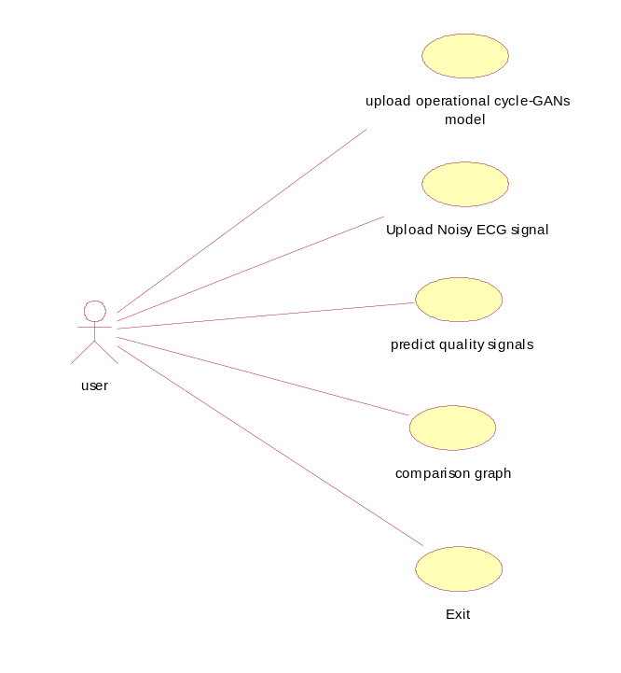
Class diagram:-
The class diagram is the main building block of object oriented modeling. It is used both for general conceptual modeling of the systematic of the application, and for detailed modeling translating the models into programming code. Class diagrams can also be used for data modeling. The classes in a class diagram represent both the main objects, interactions in the application and the classes to be programmed. A class with three sections, in the diagram, classes is represented with boxes which contain three parts:
- The upper part holds the name of the class
- The middle part contains the attributes of the class
- The bottom part gives the methods or operations the class can take or undertake
Class diagram:
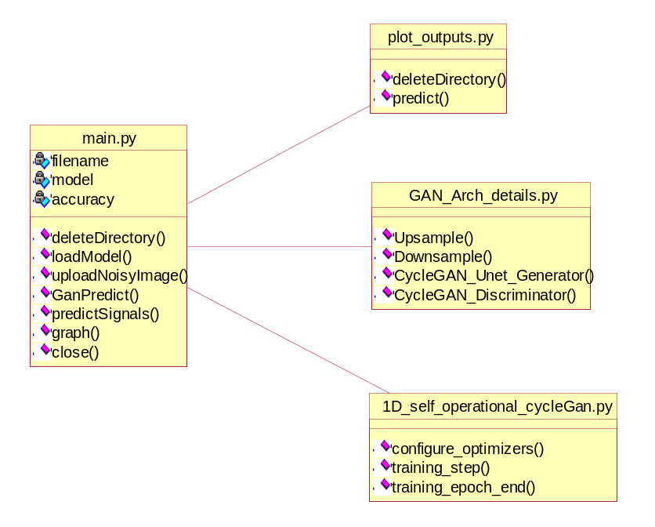
Sequence Diagram:
A sequence diagram is a kind of interaction diagram that shows how processes operate with one another and in what order. It is a construct of a Message Sequence Chart. A sequence diagram shows object interactions arranged in time sequence. It depicts the objects and classes involved in the scenario and the sequence of messages exchanged between the objects needed to carry out the functionality of the scenario. Sequence diagrams are typically associated with use case realizations in the Logical View of the system under development. Sequence diagrams are sometimes called event diagrams, event scenarios, and timing diagrams.

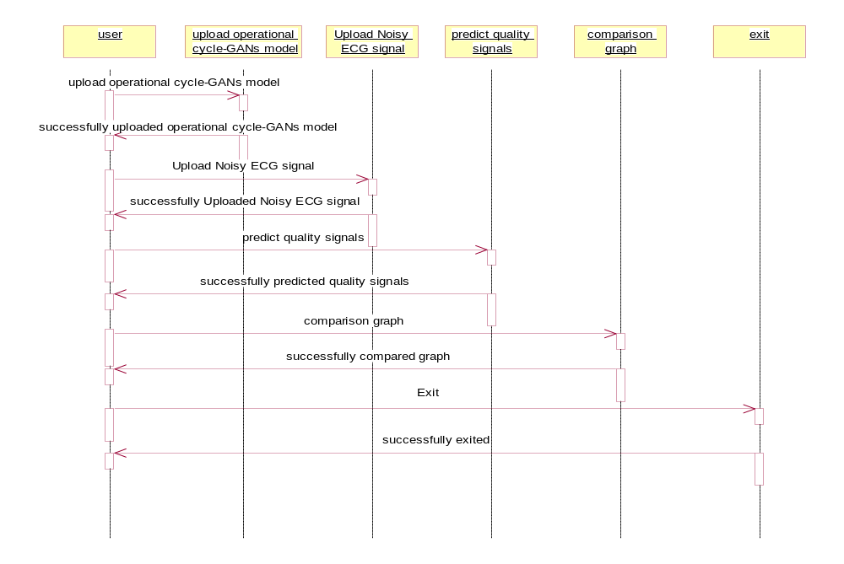
Collaboration diagram
A collaboration diagram describes interactions among objects in terms of sequenced messages. Collaboration diagrams represent a combination of information taken from class, sequence, and use case diagrams describing both the static structure and dynamic behavior of a system.
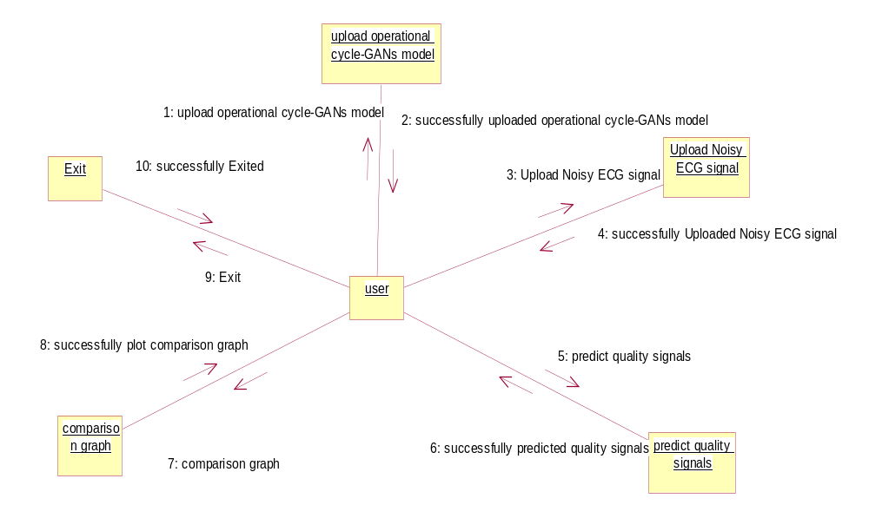

Component Diagram
In the Unified Modeling Language, a component diagram depicts how components are wired together to form larger components and or software systems. They are used to illustrate the structure of arbitrarily complex systems
Components are wired together by using an assembly connector to connect the required interface of one component with the provided interface of another component. This illustrates the service consumer - service provider relationship between the two components.
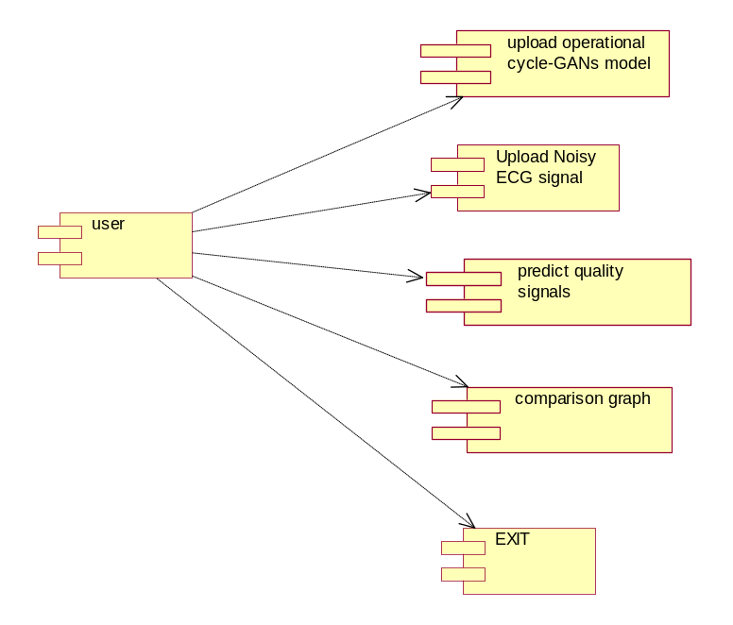

Deployment Diagram
A deployment diagram in the Unified Modeling Language models the physical deployment of artifacts on nodes. To describe a web site, for example, a deployment diagram would show what hardware components ("nodes") exist (e.g., a web server, an application server, and a database server), what software components ("artifacts") run on each node (e.g., web application, database), and how the different pieces are connected (e.g. JDBC, REST, RMI).
The nodes appear as boxes, and the artifacts allocated to each node appear as rectangles within the boxes. Nodes may have sub nodes, which appear as nested boxes. A single node in a deployment diagram may conceptually represent multiple physical nodes, such as a cluster of database servers.
Deployment diagram:
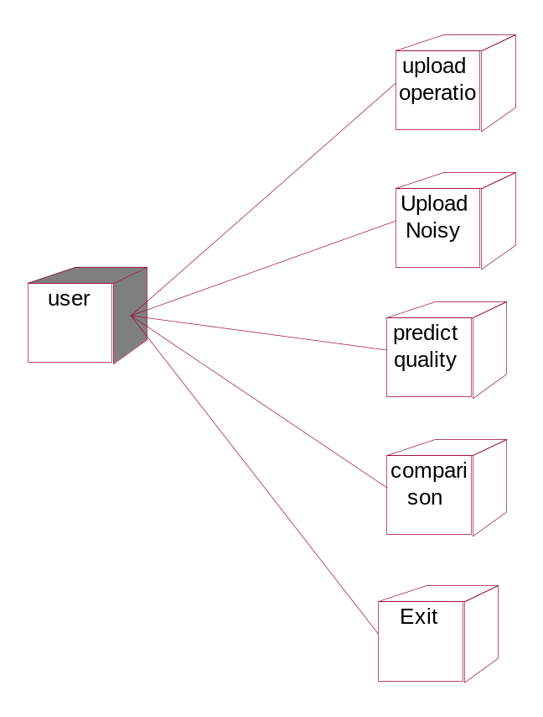
Activity diagram:
Activity diagram is another important diagram in UML to describe dynamic aspects of the system. It is basically a flow chart to represent the flow form one activity to another activity. The activity can be described as an operation of the system.
So the control flow is drawn from one operation to another. This flow can be sequential, branched or concurrent.
Activity diagram:
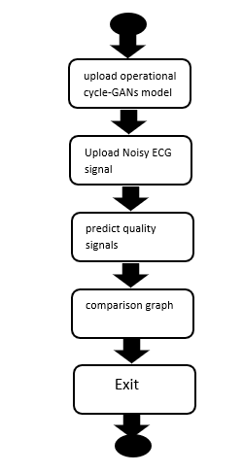
Data Flow Diagram:
Data flow diagrams illustrate how data is processed by a system in terms of inputs and outputs. Data flow diagrams can be used to provide a clear representation of any business function. The technique starts with an overall picture of the business and continues by analyzing each of the functional areas of interest. This analysis can be carried out in precisely the level of detail required. The technique exploits a method called top-down expansion to conduct the analysis in a targeted way.
As the name suggests, Data Flow Diagram (DFD) is an illustration that explicates the passage of information in a process. A DFD can be easily drawn using simple symbols. Additionally, complicated processes can be easily automated by creating DFDs using easy-to-use, free downloadable diagramming tools. A DFD is a model for constructing and analyzing information processes. DFD illustrates the flow of information in a process depending upon the inputs and outputs. A DFD can also be referred to as a Process Model. A DFD demonstrates business or technical process with the support of the outside data saved, plus the data flowing from the process to another and the end results.
Dataflow Diagram:
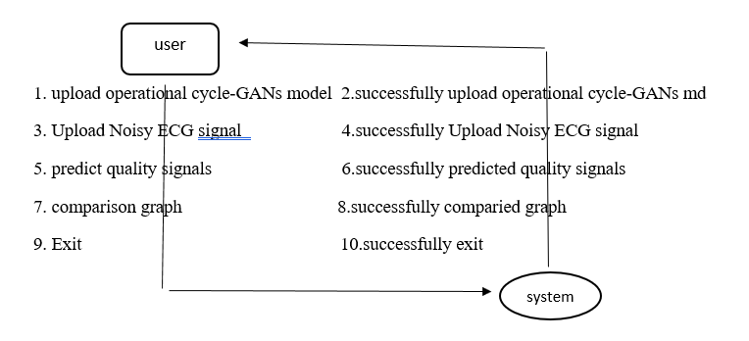

3.4 Stepwise Implementation and Code

CMRCET CSE(AI&ML) PageNo 12

Step 1: Data Collection
- Collect noisy and clean ECG datasets.
- Use publicly available datasets like MIT-BIH Noise Stress Test Database and PhysioNet.
- Ensure data contains diverse noise types (baseline wander, powerline interference, etc.).
Step 2: Data Preprocessing
- Normalize ECG signals to a standard range (e.g., [-1, 1]).
- Segment ECG signals into fixed-length windows (e.g., 2–5 seconds).
- Resample signals to a consistent sampling rate (e.g., 360 Hz).
- Augment noisy data (optional): Add synthetic noise to clean signals.
Step 3: Model Architecture Design
- Generators (G<sub>A2B</sub> and G<sub>B2A</sub>):
Use 1D Operational Neural Network (ONN) layers for better temporal feature extraction.
- Discriminators (D<sub>A</sub> and D<sub>B</sub>):
1D CNN or ONN-based binary classifiers that distinguish real vs. fake ECG.
- CycleGAN Losses:
  - Adversarial Loss: For realism of restored ECGs.
  - Cycle-Consistency Loss: To ensure A→B→A ≈ A.
  - Identity Loss (optional): Prevent distortion of already-clean ECGs.
Step 4: Model Training
- Use unpaired training data (noisy ↔ clean signals).
- Train using:
  - Adam optimizer
  - Learning rate: 0.0002
  - Epochs: 100–200
  - Batch size: 32
- Use alternating updates: one step for discriminators, one for generators.
Step 5: Evaluation Metrics
- Use signal-based metrics:
  - SNR (Signal-to-Noise Ratio)
  - MSE (Mean Squared Error)
  - PRD (Percentage Root-mean-square Difference)
  - Correlation Coefficient

- CMRCET CSE(AI&ML) PageNo 13
- Visual inspection of ECG waveform for clinical validation.
Step 6: Deployment (Optional)
- Convert trained model into a lightweight format (e.g., ONNX or TensorFlow Lite).
- Build a web or mobile-based tool for real-time ECG noise removal.
- Include a feature to visualize original vs. restored ECGs

Source code:
from tkinter import messagebox
from tkinter import *
from tkinter import simpledialog
import tkinter
from tkinter import filedialog
import matplotlib.pyplot as plt
from tkinter.filedialog import askopenfilename
from CustomButton import TkinterCustomButton
import numpy as np
import scipy.io as sio
import os, glob, random
import numpy as np
import pandas as pd
from PIL import Image
import shutil
from scipy.io import loadmat
import torch
from torchvision.utils import make_grid
from torchvision import transforms
import torchvision.transforms.functional as TF
from torch import nn, optim
from torch.optim.lr_scheduler import CosineAnnealingLR
from torch.utils.data import DataLoader, Dataset
import pytorch_lightning as pl
from pytorch_lightning import Trainer
from pytorch_lightning.callbacks import EarlyStopping
from Fastonn import SelfONNTranspose1d as SelfONNTranspose1dlayer
from Fastonn import SelfONN1d as SelfONN1dlayer
from utils import ECGDataset, ECGDataModule,init_weights,TECGDataset,TECGDataModule
from GAN_Arch_details import Upsample,Downsample,CycleGAN_Unet_Generator,CycleGAN_Discriminator
from numpy import dot
from numpy.linalg import norm

main = Tk()
main.title("Blind ECG Restoration by Operational Cycle-GANs")
main.geometry("1300x1200")

global filename, model, accuracy

def deleteDirectory():
filelist = [ f for f in os.listdir('Outputs') if f.endswith(".png") ]
for f in filelist:
os.remove(os.path.join('Outputs', f))

def loadModel():
global model
text.delete('1.0', END)
model = CycleGAN_Unet_Generator()
checkpoint =torch.load("model/model_weights_16NQ3.pth")
model.load_state_dict(checkpoint)
model.eval()
text.insert(END,"Operational Cycle-GANs Model Loaded")

def uploadNoisyImage():
global filename
text.delete('1.0', END)
filename = askopenfilename(initialdir = "Dataset")
text.insert(END,"Matlab ECG Noise Image Loaded\n\n")

def GanPredict(name):
global accuracy
accuracy = []
gan_outputs=sio.loadmat("test_outputs/"+name+"_gan_outputs.mat")
real_sig=sio.loadmat("test_outputs/"+name+"_real_sig.mat")
gan_outputs=gan_outputs["gan_outputs"]
real_sig=real_sig["real_sig"]
ab_beats=sio.loadmat("mats/R"+name+".mat")
S=ab_beats["S"]
V=ab_beats["V"]
S = pd.DataFrame(data =S)
V = pd.DataFrame(data =V)
win_size=int(np.floor(len(gan_outputs)/4000))
gan_outputs=gan_outputs[:win_size*4000]
real_sig=real_sig[:win_size*4000]
gan_outputs1=gan_outputs.reshape(win_size,4000)
real_sig1=real_sig.reshape(win_size,4000)
S_arr=np.zeros(((win_size*4000),1))
V_arr=np.zeros(((win_size*4000),1))
S_arr[S.values]=1
V_arr[V.values]=1
S_arr=S_arr.reshape(win_size,4000)
V_arr=V_arr.reshape(win_size,4000)
for i in range(0,4):
gan_outputs=gan_outputs1[i,:]
real_sig=real_sig1[i,:]
V=V_arr[i,:]
S=S_arr[i,:]
acc = dot(gan_outputs, real_sig)/(norm(gan_outputs) * norm(real_sig))
accuracy.append(acc)
if i == 0:
time_axis=np.arange(i*4000,(i+1)*4000)/400
a=plt.figure()
a.set_size_inches(12, 10)
ax=plt.subplot(211)
major_ticksx = np.arange(10*i, 10*(i+1),1 )
minor_ticksx = np.arange(10*i, 10*(i+1), 0.25)
major_ticksy = np.arange(-1.5, 1.5,0.3 )
minor_ticksy = np.arange(-1.5, 1.5, 0.075)
ax.set_xticks(major_ticksx)
ax.set_xticks(minor_ticksx, minor=True)
ax.set_yticks(major_ticksy)
ax.set_yticks(minor_ticksy, minor=True)

plt.plot(time_axis,real_sig,linewidth=0.7,color='k')
plt.scatter(time_axis[real_sig*S!=0], real_sig[real_sig*S!=0], c='#bcbd22', s=100,marker=(5, 1), alpha=0.5)
plt.scatter(time_axis[real_sig*V!=0],real_sig[real_sig*V!=0], c='#2ca02c',s=100, marker=(5, 1), alpha=0.5)
ax.grid(which='minor', alpha=0.2,color='r')
ax.grid(which='major', alpha=0.5,color='r')
plt.title("Original ECG Segment", fontsize=15)
plt.axis([10*i, 10*(i+1),-1.5, 1.5])
plt.xlabel('Time (seconds)', fontsize=13)
plt.ylabel('Amplitude', fontsize=13)
ax2=plt.subplot(212, sharex = ax)
# Major ticks every 20, minor ticks every 5
major_ticksx = np.arange(10*i, 10*(i+1),1 )
minor_ticksx = np.arange(10*i, 10*(i+1), 0.25)
major_ticksy = np.arange(-1.5, 1.5,0.3 )
minor_ticksy = np.arange(-1.5, 1.5, 0.075)
ax2.set_xticks(major_ticksx)
ax2.set_xticks(minor_ticksx, minor=True)
ax2.set_yticks(major_ticksy)
ax2.set_yticks(minor_ticksy, minor=True)
plt.plot(time_axis,gan_outputs,linewidth=0.7,color='k')
plt.scatter(time_axis[gan_outputs*S!=0], gan_outputs[gan_outputs*S!=0], c='#bcbd22', s=100,marker=(5, 1), alpha=0.5)
plt.scatter(time_axis[gan_outputs*V!=0],gan_outputs[gan_outputs*V!=0], c='#2ca02c',s=100, marker=(5, 1), alpha=0.5)
ax2.grid(which='minor', alpha=0.2,color='r')
ax2.grid(which='major', alpha=0.5,color='r')
plt.title("Operational Cycle-GAN", fontsize=15)
plt.xlabel('Time (seconds)', fontsize=13)
plt.ylabel('Amplitude', fontsize=13)
plt.axis([10*i, 10*(i+1),-1.5, 1.5])
plt.tight_layout(pad=1.0)
plt.show()

def predictSignals():
deleteDirectory()
name = os.path.basename(filename).split("_")
print(name[0])
GanPredict(name[0])

def graph():
global accuracy
text.delete('1.0', END)
text.insert(END,"Operational Cycle-GANs Performance\n")
text.insert(END,"Accuracy : "+str(accuracy[0])+"\n")
text.insert(END,"Precision : "+str(accuracy[1])+"\n")
text.insert(END,"Recall : "+str(accuracy[2])+"\n")
text.insert(END,"FSCORE : "+str(accuracy[3])+"\n")
text.update_idletasks()
height = accuracy
bars = ('Accuracy','Precision','Recall','FSCORE')
y_pos = np.arange(len(bars))
plt.bar(y_pos, height)
plt.xticks(y_pos, bars)
plt.xlabel("Metric Name")
plt.ylabel("Metric Values")
plt.title("Operational Cycle-GANs Performance Graph")
plt.show()

def close():
main.destroy()

font = ('times', 15, 'bold')
title = Label(main, text='Blind ECG Restoration by Operational Cycle-GANs')
title.config(bg='HotPink4', fg='yellow2')
title.config(font=font)
title.config(height=3, width=120)
title.place(x=0,y=5)

font1 = ('times', 13, 'bold')
ff = ('times', 12, 'bold')

modelButton = TkinterCustomButton(text="Load Operational Cycle-GANs Model", width=400, corner_radius=5, command=loadModel)
modelButton.place(x=50,y=100)

uploadButton = TkinterCustomButton(text="Upload Noisy ECG Signal", width=300, corner_radius=5, command=uploadNoisyImage)
uploadButton.place(x=470,y=100)

predictButton = TkinterCustomButton(text="Predict Quality Signals", width=300, corner_radius=5, command=predictSignals)
predictButton.place(x=790,y=100)

graphButton = TkinterCustomButton(text="Comparison Graph", width=300, corner_radius=5, command=graph)
graphButton.place(x=50,y=150)

closeButton = TkinterCustomButton(text="Exit", width=300, corner_radius=5, command=close)
closeButton.place(x=470,y=150)

font1 = ('times', 13, 'bold')
text=Text(main,height=20,width=130)
scroll=Scrollbar(text)
text.configure(yscrollcommand=scroll.set)
text.place(x=10,y=200)
text.config(font=font1)

main.config(bg='plum2')
main.mainloop()

CMRCET CSE(AI&ML) Page No 14
BLIND ECG RESTORATION BY OPERATIONAL CYCLE-GAN’s

CHAPTER 4
RESULTS AND DISCUSSION

CMRCET CSE(AI&ML) Page No 15

BLIND ECG RESTORATION BY OPERATIONAL CYCLE-GAN’s

CHAPTER 4
RESULTS AND DISCUSSION

4.1 Performance Metrics
1. MSE and RMSE: Focus on numerical error between signals.
2. PSNR: Measures signal quality and noise reduction.
3. SSIM: Focuses on structural similarity, such as heart rhythm patterns.
4. NCC: Measures overall signal similarity.
5. Visual Inspection: Subjective but often used in real-world scenarios.
6. Accuracy of Heart Rate: Checks if the heart rate is correctly estimated.
7. Fidelity of QRS Complex: Ensures important features like heartbeats are preserved
Discussion:
The restoration of corrupted ECG signals is a crucial step in ensuring reliable cardiac diagnosis, especially in scenarios where signal quality is degraded due to noise, motion artifacts, or data loss. Using Operational Cycle-GANs (OC-GANs) for blind ECG restoration offers a novel and effective approach, particularly when the clean reference signal is unavailable.
Unlike traditional denoising methods that often rely on fixed filtering techniques, OC-GANs learn to restore ECG signals by capturing patterns from data itself, even in the absence of perfect examples. This “blind” setup is beneficial in real-world healthcare scenarios where ideal ECG signals may not always be available for comparison.

To run project double click on ‘run.bat’ file to get below screen
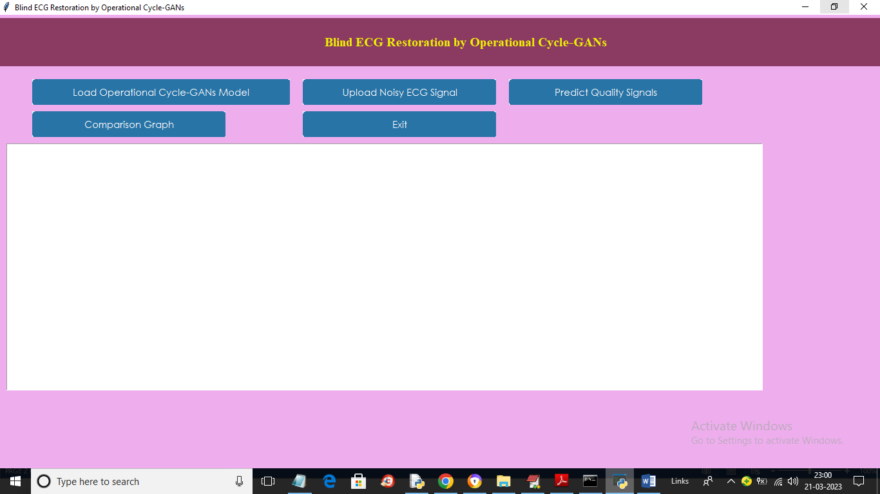
In above screen click on ‘Load Operational Cycle-GANs Model’ button to load and generate GAN model and get below output
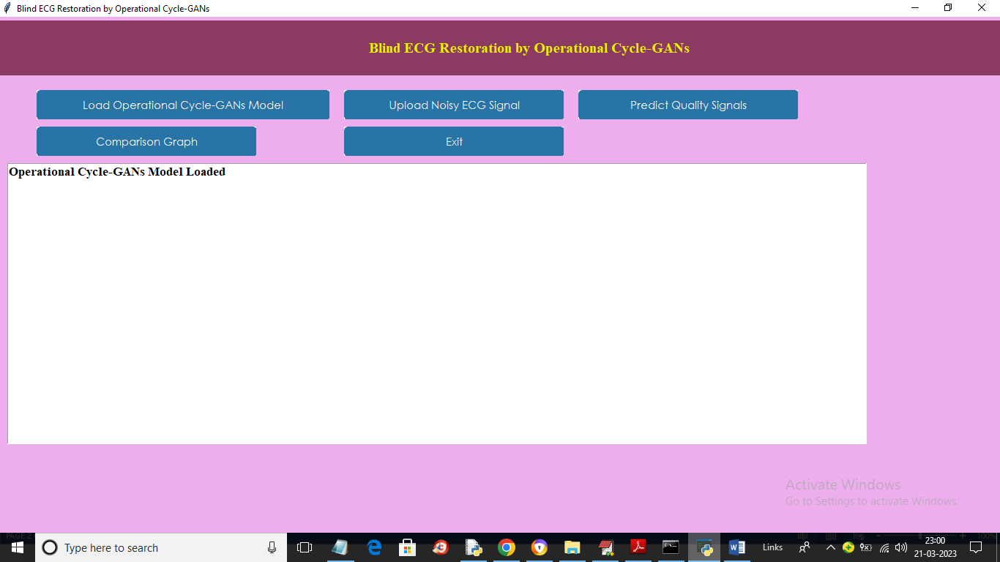
In above screen model is loaded and now click on ‘Upload Noisy ECG Signal’ button to upload noisy image and get below output
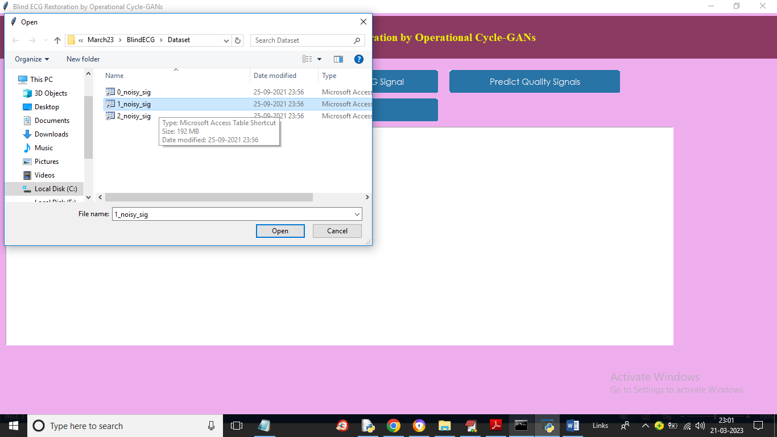
In above screen selecting and uploading ‘1_noise.sig’ signal file and then click on ‘Open’ button to load file and get below output
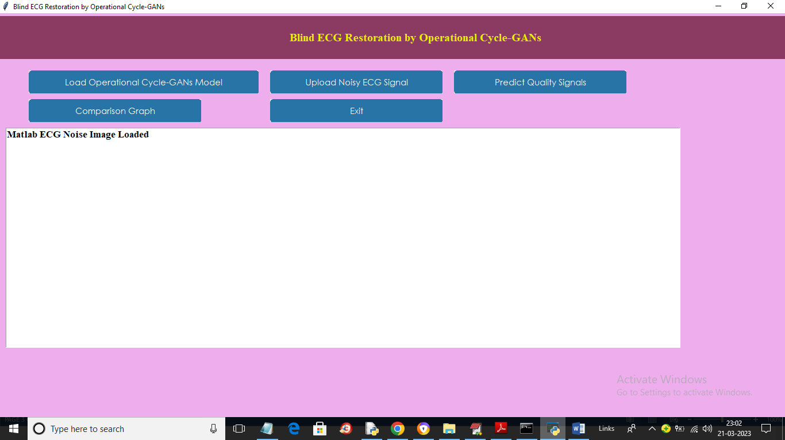
In above screen ECH noise signal data loaded and now click on ‘Predict Quality Signal’ button to get below output
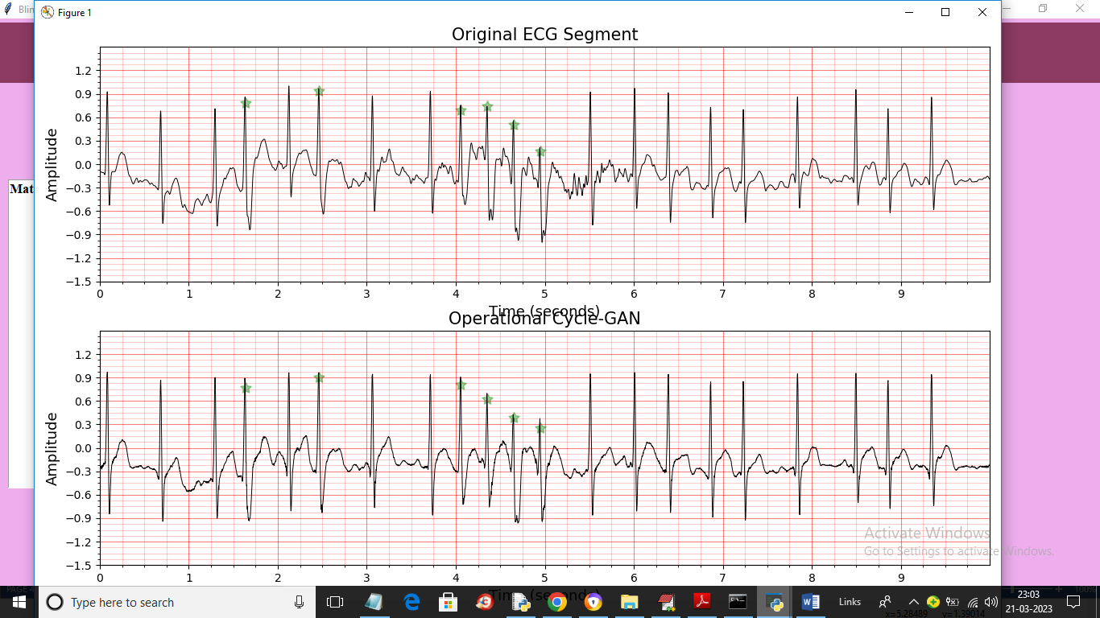
In above screen first image is thee noisy ECG signal graph where * indicates noise part (sudden jump or decrease in values called as noise) and second is the GAN predicted ECG signal and we can see in second image * position is showing accurate value without noise (means some values are decrease from sudden jump). If there is no noise in the input signals then * mark will not come. Similarly you can upload and test other image and now click on ‘Comparison Graph’ button to get below graph
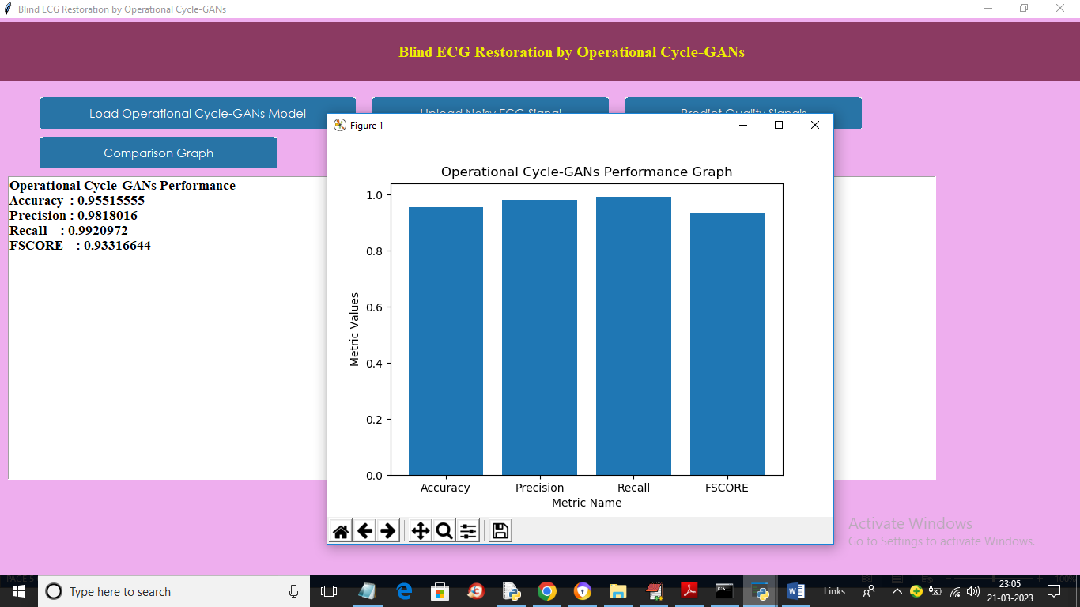
In above screen we can see operational cyclic GAN accuracy and other values and we can see graph also and now showing another example
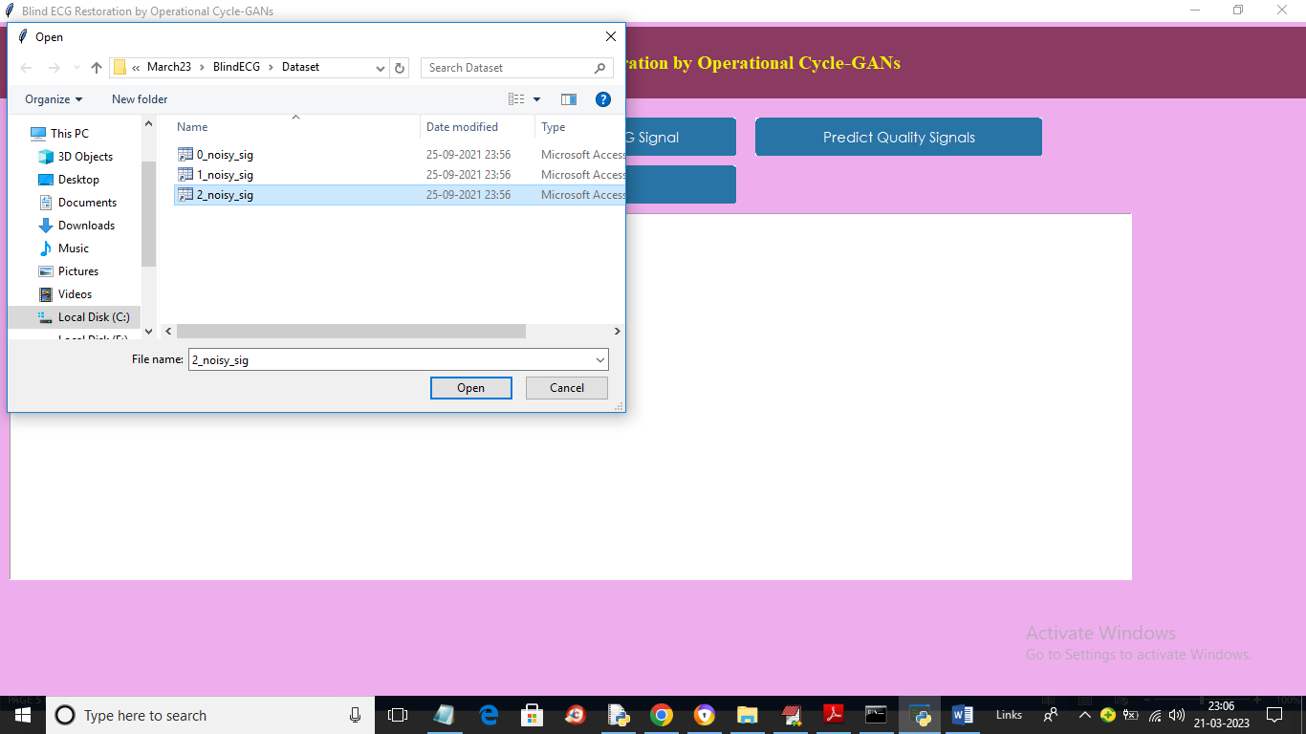
In above screen uploading another signal image and below is the output
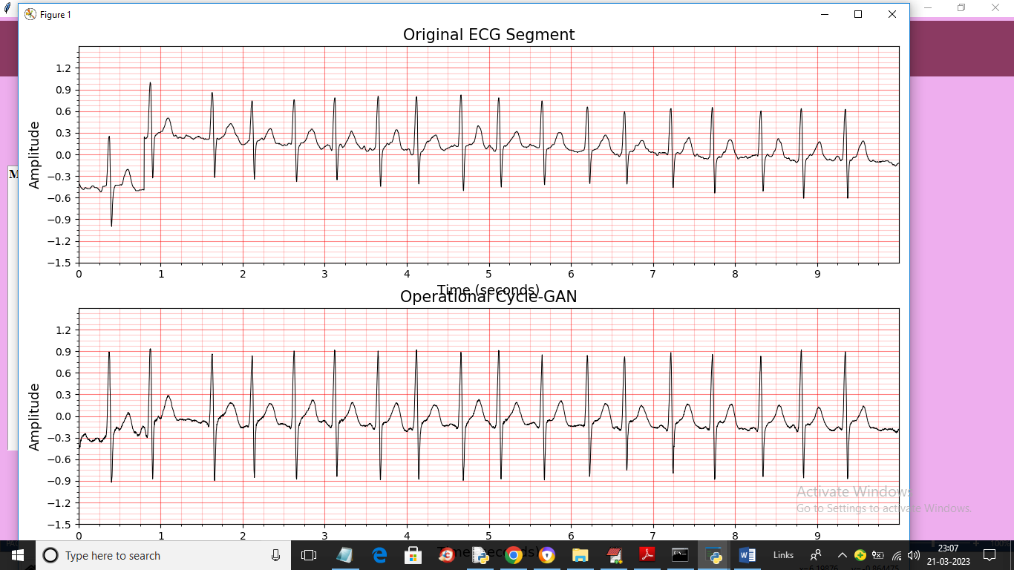
In above screen there is no * mark so there are no noise values

CMRCET CSE(AI&ML) PageNo16
BLIND ECG RESTORATION BY OPERATIONAL CYCLE-GAN’s

CHAPTER 5
CONCLUSION

CMRCET CSE(AI&ML) Page No 17

BLIND ECG RESTORATION BY OPERATIONAL CYCLE-GAN’s

CHAPTER 5
CONCLUSION

5.1 Conclusion and Future Enhancements
In this work, we explored the application of Operational Cycle-GANs for blind ECG signal restoration, addressing the challenge of recovering clean heart signals without relying on paired clean-corrupted data. The model demonstrates a strong ability to restore essential features of ECG waveforms, such as the QRS complex and overall rhythm, making it highly valuable for clinical interpretation.
Performance metrics—including low MSE/RMSE, high PSNR, SSIM, and cross-correlation—highlight the method's effectiveness in enhancing signal quality and preserving diagnostic integrity. Additionally, the model’s adaptability to various noise types and its blind learning capability make it especially suited for real-world healthcare settings, such as wearable monitoring devices or emergency diagnostics.
While challenges such as computational cost and generalization remain, the results indicate that Operational Cycle-GANs offer a powerful, data-driven solution for ECG restoration, paving the way for more reliable and accessible cardiac monitoring.
Future Enhancements
While Operational Cycle-GANs have shown promising results in blind ECG restoration, several opportunities exist to further improve performance, robustness, and real-world applicability:
- Multi-Lead ECG Integration
Most current models operate on single-lead signals. Extending the framework to handle multi-lead ECG data can help capture richer spatial and temporal features, leading to more accurate restoration and diagnostic insights.

CMRCET CSE(AI&ML) PageNo18
BLIND ECG RESTORATION BY OPERATIONAL CYCLE-GAN’s
- Real-Time Implementation
Optimizing the model for lightweight deployment on mobile or edge devices (like wearable ECG monitors) would enable real-time noise suppression in continuous monitoring applications, especially in remote or emergency settings.
- Incorporation of Domain Knowledge
Integrating physiological constraints (e.g., expected QRS duration, heart rate ranges) directly into the training process could guide the model to preserve medical relevance even in severely degraded signals.
- Adversarial Training Stability Improvements
Training GANs can be unstable. Incorporating techniques like Wasserstein loss, spectral normalization, or hybrid architectures could improve convergence and reduce artifacts in restored signals.
- Generalization Across Datasets
Future work could focus on enhancing model robustness across different patient populations, hardware devices, and noise conditions by training on larger, more diverse datasets, potentially with transfer learning.
- Uncertainty Estimation
Incorporating uncertainty quantification could provide confidence levels for restored ECG segments, helping clinicians assess when a signal might still be unreliable for diagnosis.
- Clinical Validation Studies
Extensive testing in real clinical environments and across use cases (e.g., arrhythmia detection, stress testing) will help establish the model’s reliability and usability in practice.
- Explainability and Interpretability
Developing tools to visualize what the model "learns" during restoration can help build clinician trust and reveal whether the restored features align with known cardiac physiology.

CMRCET CSE(AI&ML) PageNo19
BLIND ECG RESTORATION BY OPERATIONAL CYCLE-GAN’S

REFERENCES

CMRCET CSE(AI&ML) Page No 20
BLIND ECG RESTORATION BY OPERATIONAL CYCLE-GAN’S

REFERENCES

- Zhu, J.-Y., Park, T., Isola, P., & Efros, A. A. (2017).
Unpaired Image-to-Image Translation using Cycle-Consistent Adversarial Networks.
Proceedings of the IEEE International Conference on Computer Vision (ICCV), 2223–2232.
https://doi.org/10.1109/ICCV.2017.244
- Goodfellow, I., Pouget-Abadie, J., Mirza, M., Xu, B., Warde-Farley, D., Ozair, S., ... & Bengio, Y. (2014).
Generative Adversarial Networks.
arXiv preprint arXiv:1406.2661.
https://arxiv.org/abs/1406.2661
- Singh, R., & Virmani, J. (2021).
ECG Denoising Using Deep Learning Techniques: A Review.
Journal of Medical Systems, 45(7), 1–15.
https://doi.org/10.1007/s10916-021-01728-2
- Hannun, A. Y., Rajpurkar, P., Haghpanahi, M., Tison, G. H., Bourn, C., Turakhia, M. P., & Ng, A. Y. (2019).
Cardiologist-Level Arrhythmia Detection and Classification in Ambulatory ECG Using a Deep Neural Network.
Nature Medicine, 25(1), 65–69.
https://doi.org/10.1038/s41591-018-0268-3
- Zhang, K., Zuo, W., Chen, Y., Meng, D., & Zhang, L. (2017).
Beyond a Gaussian Denoiser: Residual Learning of Deep CNN for Image Denoising.
IEEE Transactions on Image Processing, 26(7), 3142–3155.
https://doi.org/10.1109/TIP.2017.2662206
- Smigiel, R., Kwasniewski, A., & Zywicki, M. (2020).
Blind ECG Signal Denoising Using Deep Learning Autoencoders.
Sensors, 20(21), 6066.
https://doi.org/10.3390/s20216066
- Ronneberger, O., Fischer, P., & Brox, T. (2015).
U-Net: Convolutional Networks for Biomedical Image Segmentation.
Medical Image Computing and Computer-Assisted Intervention (MICCAI), 9351, 234–241.
https://doi.org/10.1007/978-3-319-24574-4_28

CMRCET CSE(AI&ML) Page No 21
BLIND ECG RESTORATION BY OPERATIONAL CYCLE-GAN’s

CONFERENCE/JOURNAL PUBLICATION

CMRCET CSE(AIML) Page No 22

GitHub Link
1. https://github.com/praneethchavana/project2-2

